**PLASTIC**

E-Project for <Semester 1.>

---

<POLYSITE>

---

|  |  |
| --- | --- |
| **Authors** | **Aptech – C2411L-NK - Group : 2** |
| 1. KHAI DAO DUC - 1633994 [(Leader)] 2. DUY DO DUC - 1596443 3. VU NGUYEN HOANG - 1645360 4. TUAN NGUYEN PHAN NGOC - 1604995 |
| **Centre Name** | Aprotrain Aptech |
| **Date** | 18th December, 2025 |
| Course | ACCP |
| Curriculum Code | OV-7091-ACCP |
| **Semester** | Semester 1 |
| **Instructor** | LE THANH TU |

**Ho Chi Minh City, 18/12/2025**

**TABLE OF CONTENTS**

Clearly organized list of document sections and subsections

1. **Introduce eProject – Project name:** 4
2. Problem definition of project 4
3. List of Inputs to the Website 5
4. List of Outputs Expected from the Website 6
5. Overview of Processes Involved in the Website 7
6. Hardware and Software Required for Implementing the Project 8
7. Flow chart 9
8. Table assigning tasks to members (Leader) 10
9. **Instruction to run the project** 11
   1. Import database and tables into SQL Server 11
   2. Import Project into Visual Studio Code 13
   3. Run Web Application (Web Admin): 16
10. *Login 16*
11. *Manage Information 16*
12. *Products 16*
13. *Categories 18*
14. *Blogs 20*
15. *Users 22*
16. *Messages 23*
17. *Reviews 24*
18. *Visitor 24*
    1. Run Web Application (Web User): 25
19. *Header / Footer 25*
20. *Home Page 25*
21. *Login 28*
22. *Register 28*
23. *Profile / Logout 29*
24. *About Us Page 29*
25. *Contact Us Page 30*
26. *Products 31*
27. *Blogs 32*
28. *AI Assistant 33*
    1. Database 34
29. *ER Diagram 34*
30. *Detail of Tables 34*
    1. Contributions 36

**INTRODUCE EPROJECT – PROJECT NAME**

* + - 1. **Problem definition of project:**

PolySite makes awesome plastic bottles—the PET, PP, and PC kinds—for all sorts of industries. But right now, we're stuck. We don't have a great online space to show off what we make and connect with our customers. In today's digital world, where everyone expects easy online service, this is really holding us back from growing!

That's why we urgently need a modern website! We need a beautiful, simple-to-use platform where customers can easily browse our complete product lineup, see the detailed specs, check the latest prices, view high-quality photos, and grab important documents.

This isn't just a basic site. It needs to be smart: users must be able to register, save their favorite products, and manage documents. On our side, we need a secure, powerful admin dashboard to efficiently handle products, customers, and all website content. It has to look and work perfectly on every device and browser (Chrome, Firefox, Edge).

To truly stand out, our new site must be a flexible, fast Single-Page Application (SPA), meaning users can jump between pages without annoying reloads. We need a visually stunning design with smooth animations, interactive galleries, and dynamic elements like color-changing menus. Everything—from bottle specs to company contact info—needs to be organized clearly and accessibly. This new digital hub will transform PolySite into a professional, user-focused, and high-performing online business.

* + - 1. **List of Inputs to the Website:**
* Admin:
* Login credentials (email, password)
* Create / Read / Update / Delete (CRUD):
  + Products & their variants
  + Categories
  + Blogs
  + Registered accounts
* Receive and process Contact messages (set action if it’s handled)
* Search parameters
* Sorting selection
* User:
  + - * Register / Login (username, email, password)
      * Search parameters
      * Sorting selection
      * Favorite products marking
      * Download product documents
      * Contact messages
      * Product reviews & stars rating
      * AI chatbot prompts
      1. **List of Outputs Expected from the Website**
* Admin:
  + - * Effective dashboard that tracks:
        + Visitor count (both daily & all time)
        + Low-stock product
        + Product reviews from users and average rating
      * Interface for managing:
        + Products & variants
        + Categories
        + Users accounts
        + Blogs
        + Contact messages
* User:
  + - * Frontend:
        + Home page with convenient navigation to other pages
        + Product catalog with category filtering/sorting
        + Product detail (specs, add to favorites, download document, review)
        + View favorite products (if logged in)
        + Blogs (content, author)
        + About us & Contact pages
        + AI assistant for knowledge support
      * System response:
        + Form validation messages
        + Success / error notifications
        + Search / filtering results
        + Chatbot response
      1. **Overview of Processes Involved in the Website**
* Admin Processes:
  + Authentication: Login & Grant administrator access
  + Content Management: CRUD products, variants, blogs, categories, messages
  + User Management: View registered account & edit account details
  + Inquiry Management: Receive and handle users’ inquiries
  + Analytic Control: Track website traffic to improve user experience
* User Processes:
  + Browsing & Navigation: Explore through pages, view products, download product documents, read blogs and company information
  + Authentication: Registered account & Login to use special features such as save product to favorite list
  + Communication: Submit inquiries & product reviews / rating
* System Processes
  + Data Processing: Handle requests, form submissions & database operations
  + Security Restriction: Authenticate users & admins, use middleware to protect data and restrict access
  + UX / UI Optimization: Load content quickly using cache storage, ensure responsiveness
    - 1. **Hardware and Software Required for Implementing the Project**
* Hardware:
* Machine:
  + Intel Core i3 / i5 or AMD Ryzen 3 / 5 or better processor
  + A minimum of 8 GB RAM or better (16 GB RAM is recommended)
  + 20 GB of available Hard Disk place
* Network: Stable internet connection for deployment
* Additional devices:
  + Keyboard
  + Mouse
  + Screen Monitor
* Software:
  + - * Operating System: Window, MacOS or Linux
      * Development Stack: XAMPP / WAMP / MAMP (Apache, MySQL, phpMyAdmin), PHP 8.1+ with extensions, MySQL 5.7+ or MariaDB 10.3+
      * Framework & Tools: Laravel 10.x, Composer, Visual Studio Code IDE
      * Reliable browser (Google Chrome / Firefox / Microsoft Edge /…)
      1. **Flow chart of User**
* Admin:

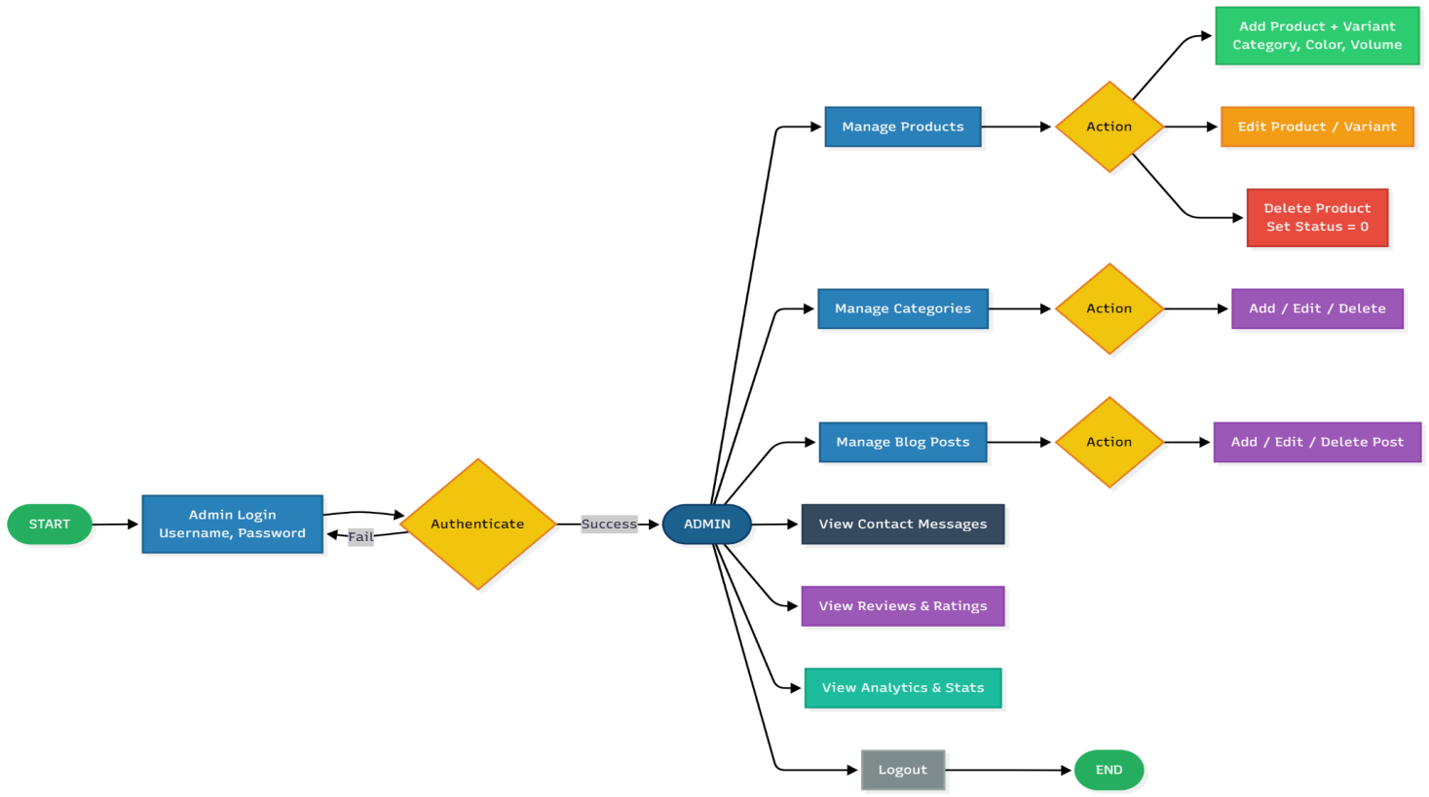

* User:

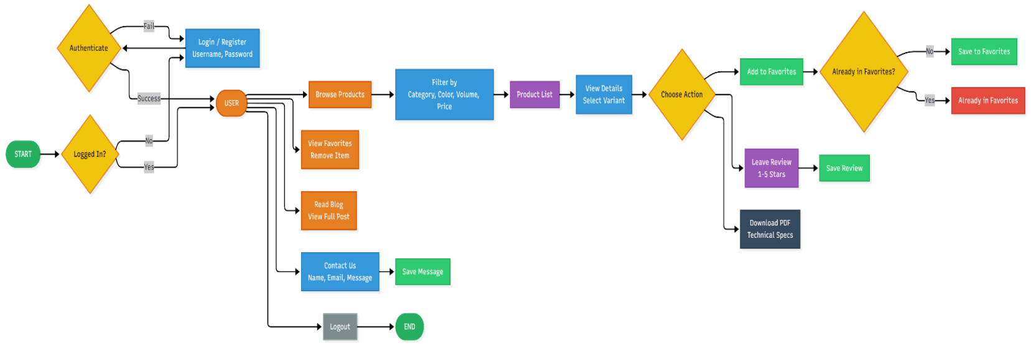

* 1. **Table assigning tasks to members (for Leader)**

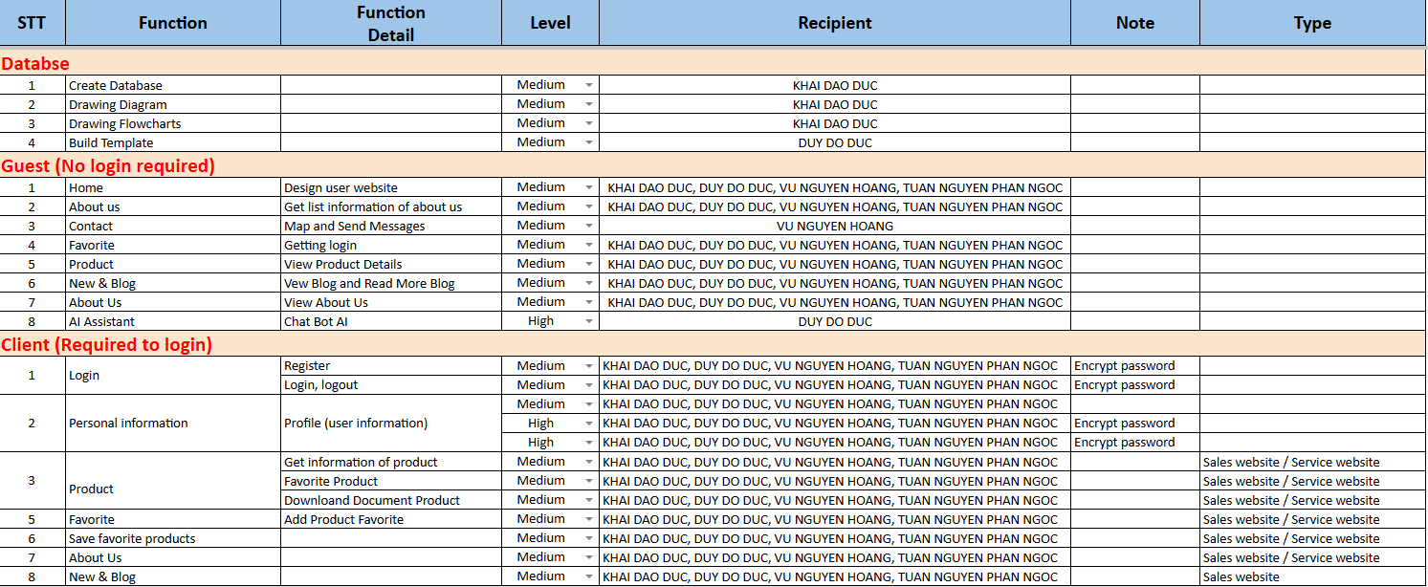



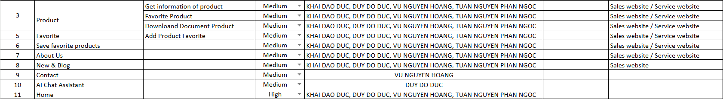

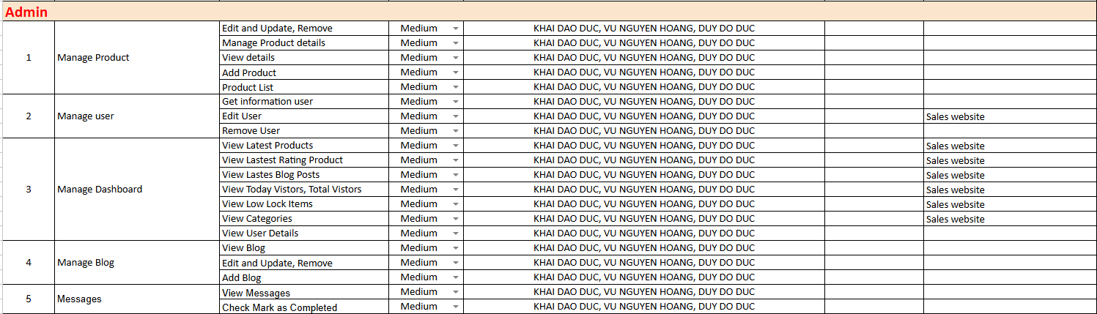

**INSTRUCTION TO RUN THE PROJECT**

1. **Import database and tables into SQL Server**

* Start Apache and MySQL in XAMPP, open [phpMyAdmin](http://localhost/phpmyadmin)

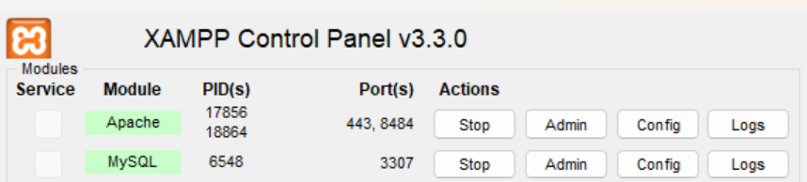

Image 1.1: Start services in XAMPP

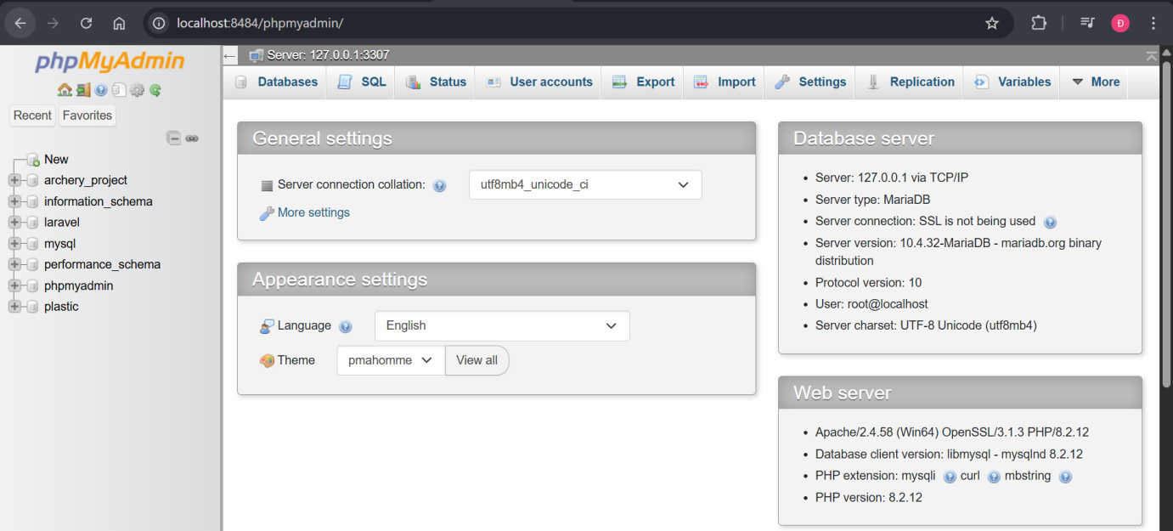

Image 1.2: Open phpMyAdmin

* Create a new database namedplasticand import the plastic.sql file

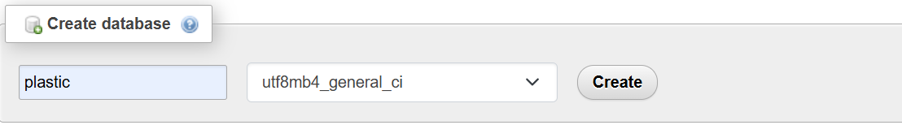

Image 1.3: Create a database named plastic

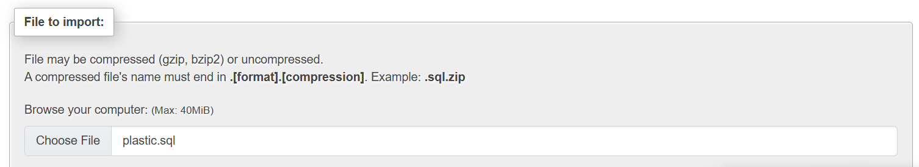

Image 1.4: Import file plastic.sql

1. **Import Project into Visual Studio Code**

* Launch the project folder in Visual Studio Code (or your preferred IDE)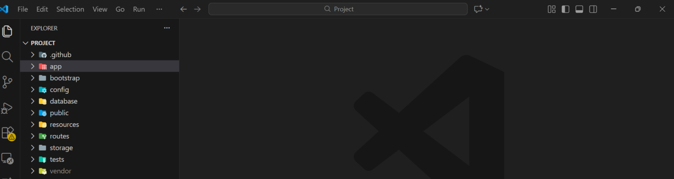

Image 2.1: Start IDE

* Copy the file env.example, rename the copy to .env and configure the settings

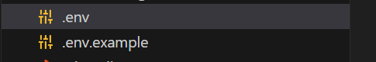

Image 2.2: Create .env file

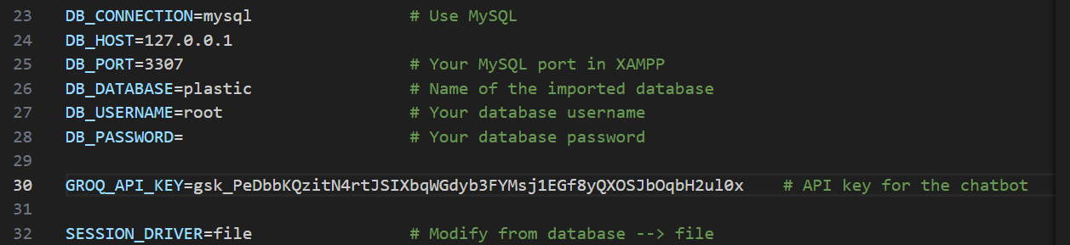

Image 2.3: Configure settings in .env



Image 2.4: Set CACHE_STORE to file

* Open terminal tab and run the command composer install to install dependencies (the folder called vendor)

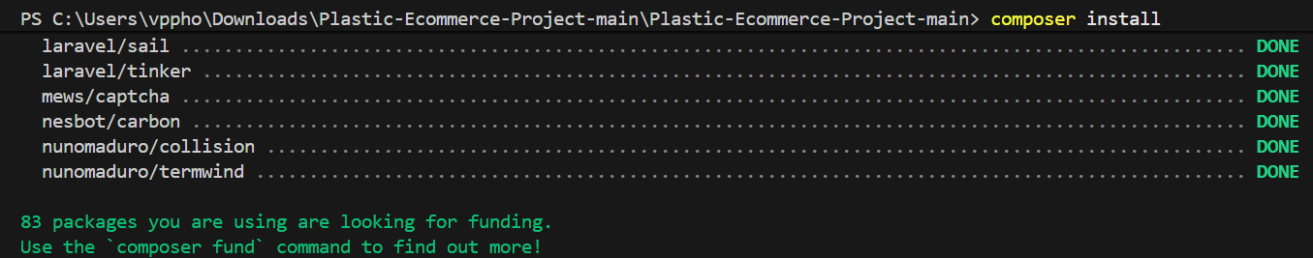

Image 2.5: Install dependencies



Image 2.6: Folder vendor

* Generate Application Key by command php artisan key:generate to secure user sessions and encrypt data



Image 2.7: Generate Application Key



Image 2.8: Example of Application Key

* Install package mews/captcha

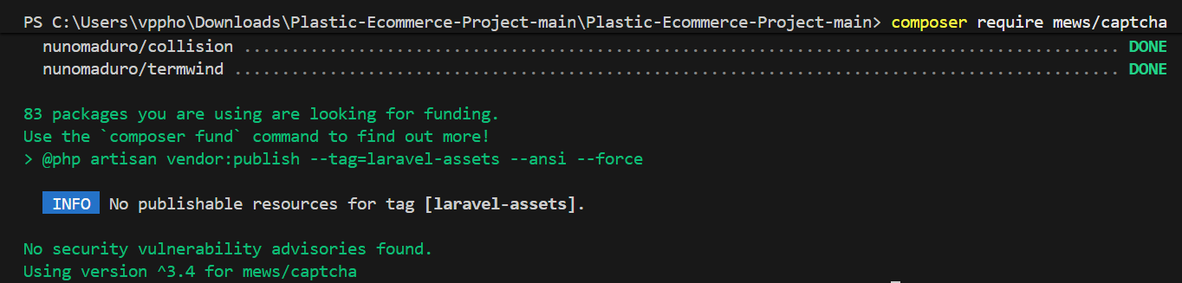

Image 2.9: Install packages for captcha

* Open public/.htaccess file and add this line

RewriteBase / Plastic-Ecommerce-Project / public



Image 2.10: Modify .htaccess

* **Verify if GD is activated using command “php -m | findstr /i "gd”**



Image 2.11: GD activation verification

* **If you don’t see any output, locate and open file php.ini and remove (;) at the beginning of this line**



Image 2.12: Fixing GD extension issue

* **Clear the cache using command “php artisan cache:clear” and start the project using command “php artisan serve”**

1. **Run Web Application (Web Admin):** 
   1. **Login**

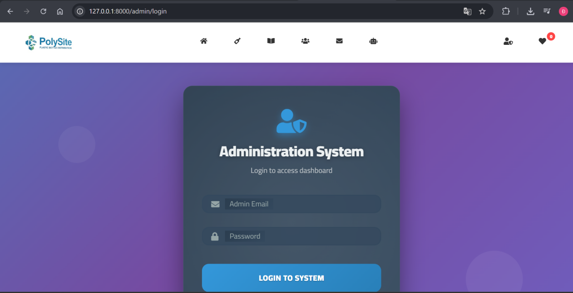

Image A: Admin Login Portal

* 1. **Information Management**
     1. **Products**

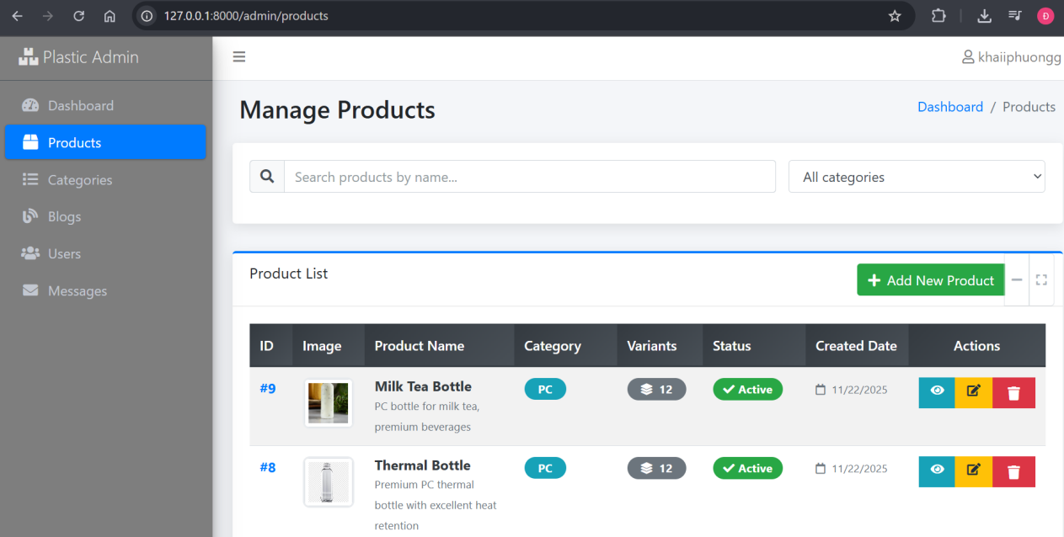

Image B1.1: Main Product Manage View

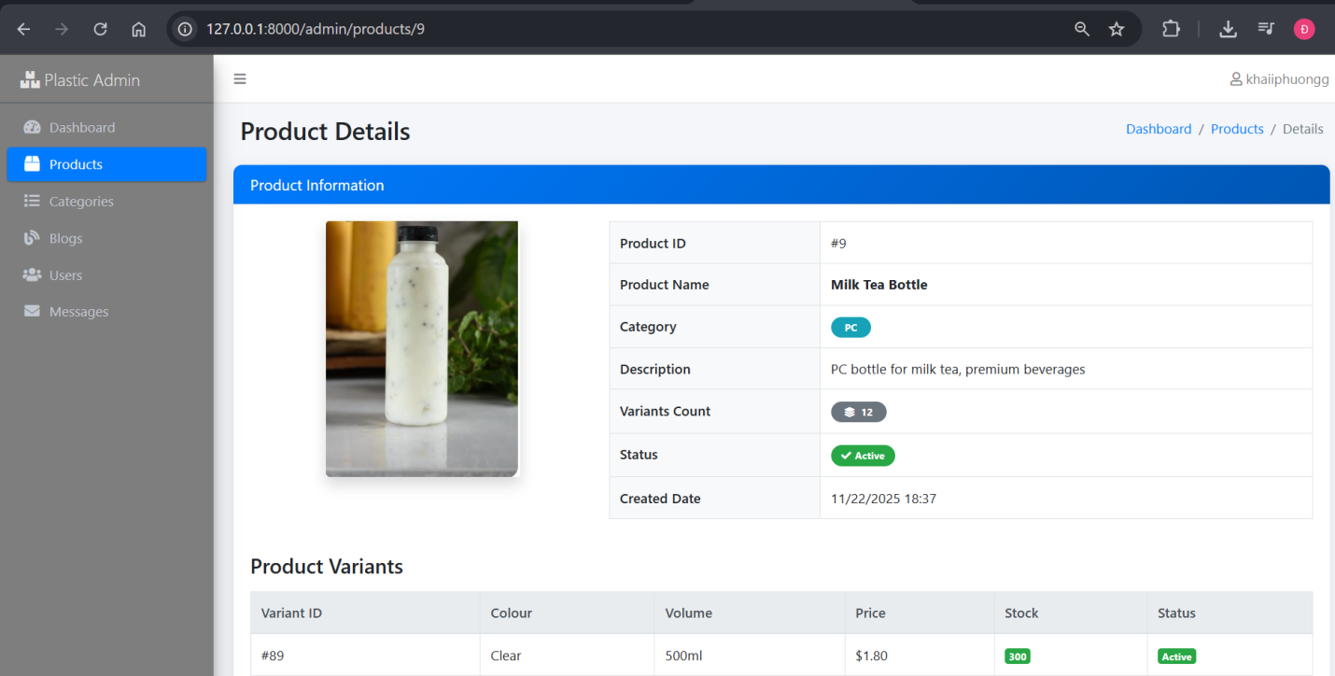

Image B1.2: Product Detail View

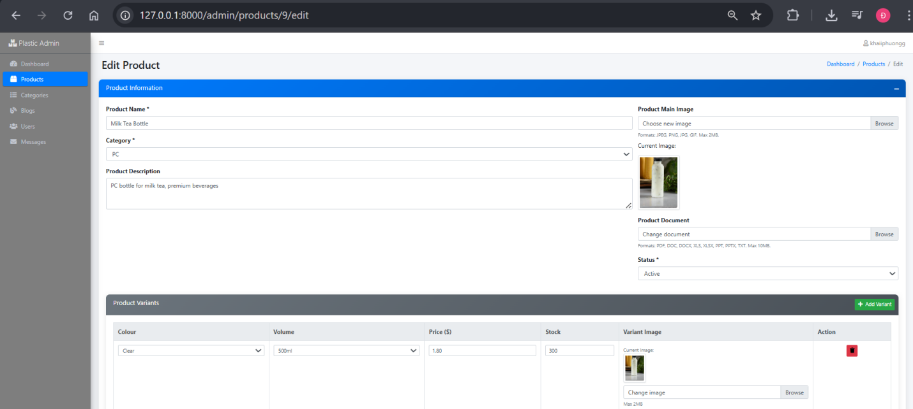

Image B1.3: Product Edit View

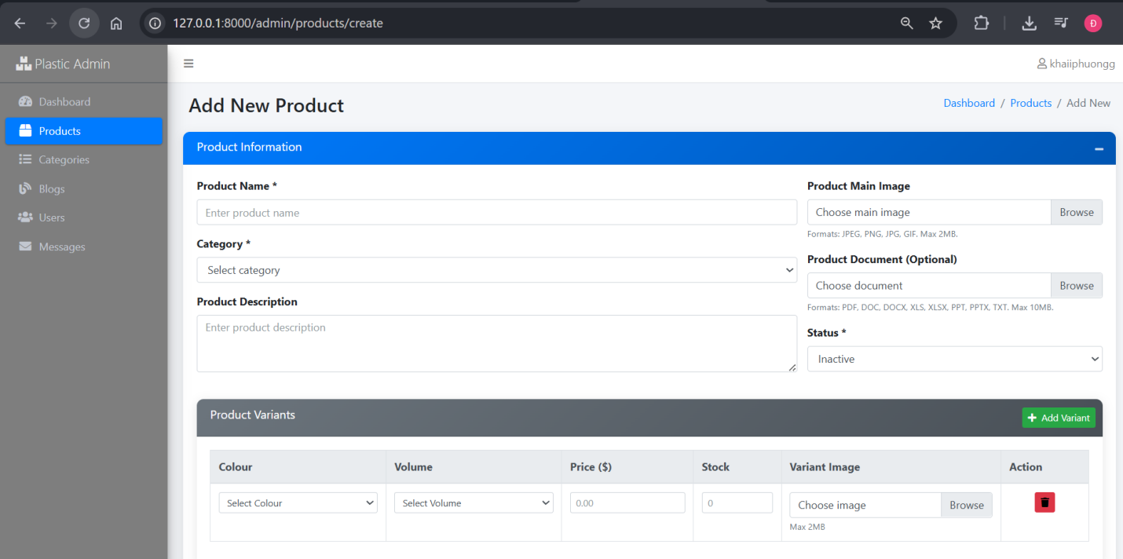

Image B1.4: Product Adding View

* + 1. **Categories**

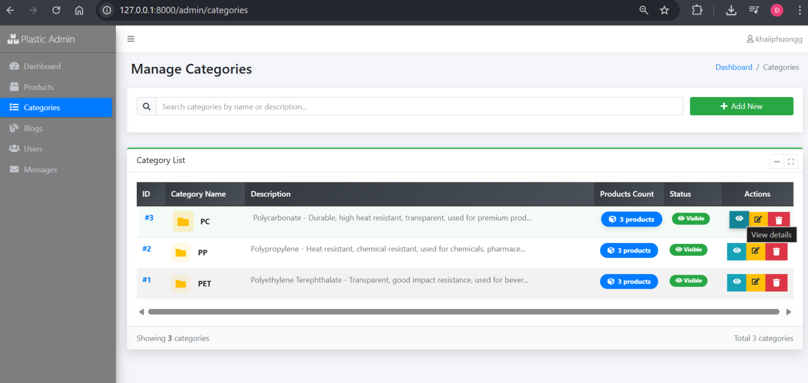

Image B2.1: Main Categories Management View

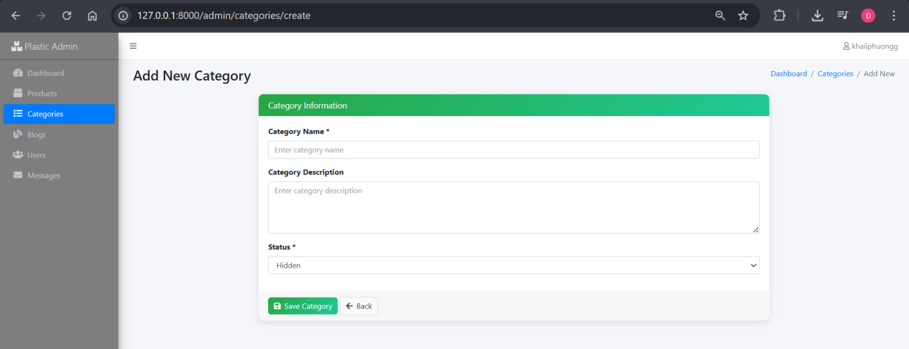

Image B2.2: Category Adding View

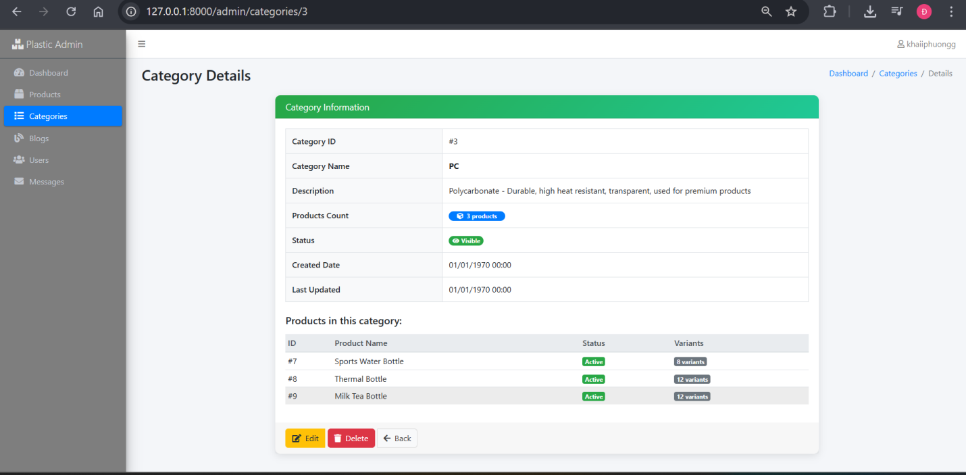

Image B2.3: Category Detail View

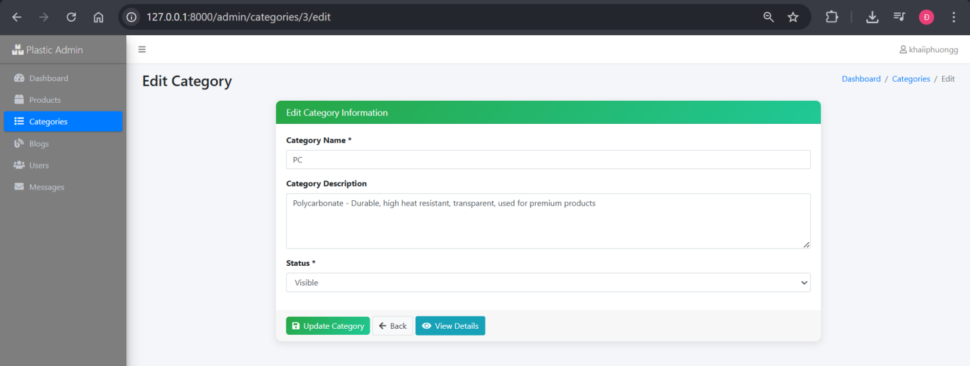

Image B2.4: Category Edit View

* + 1. **Blogs**

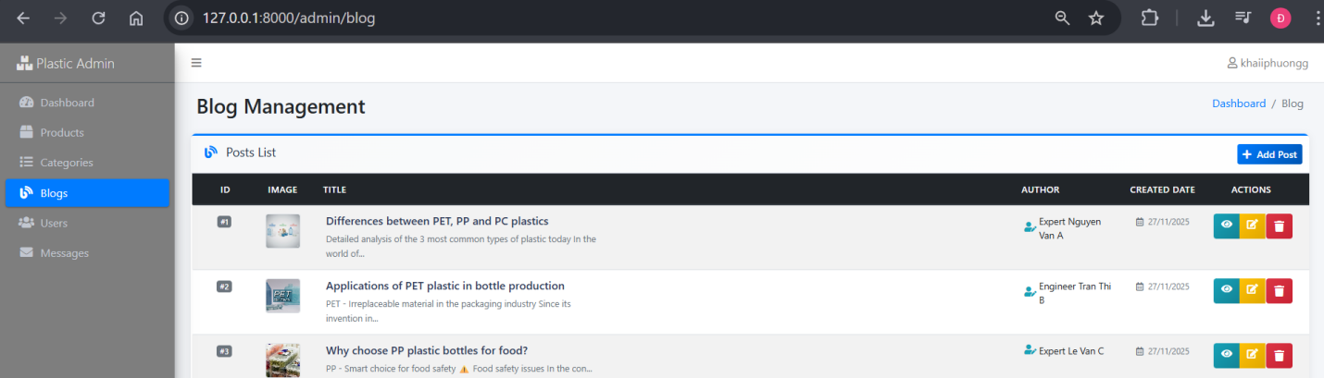

Image B3.1: Main Blog Management View

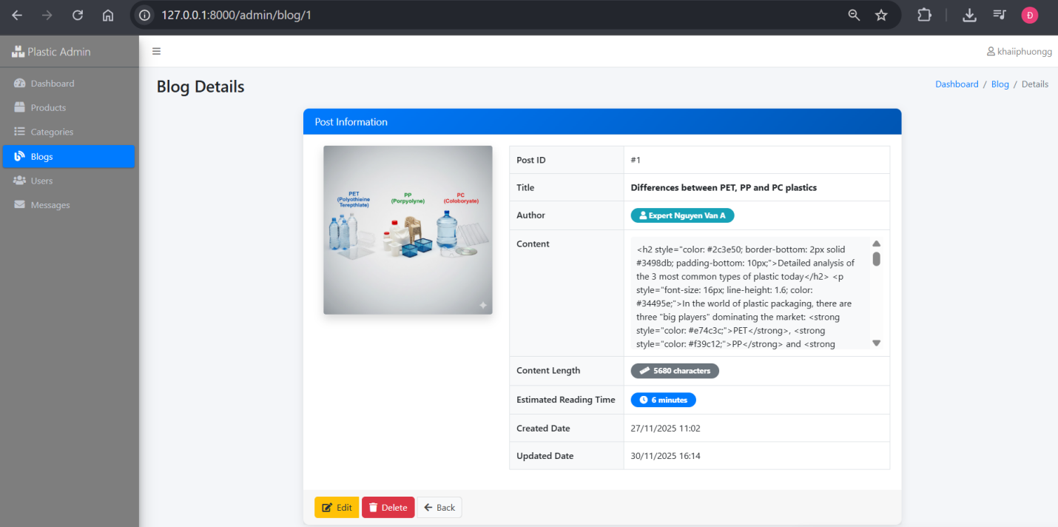

Image B3.2: Blog Detail View

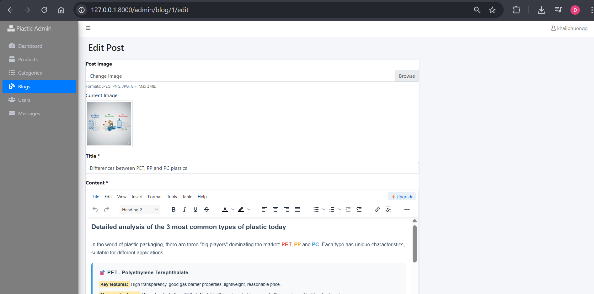

Image B3.3: Blog Edit View

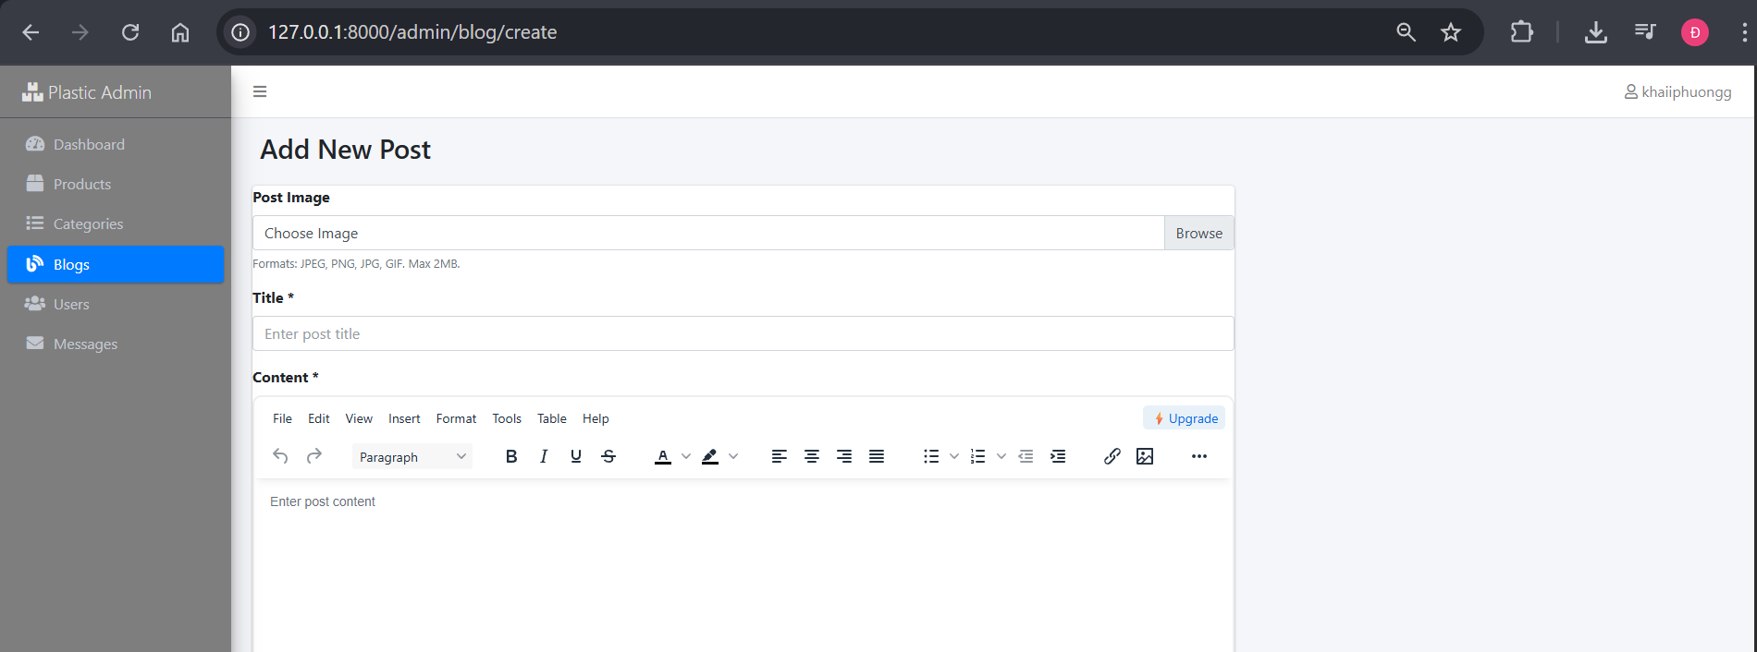

Image B3.4: Blog Adding View

* + 1. **Users**

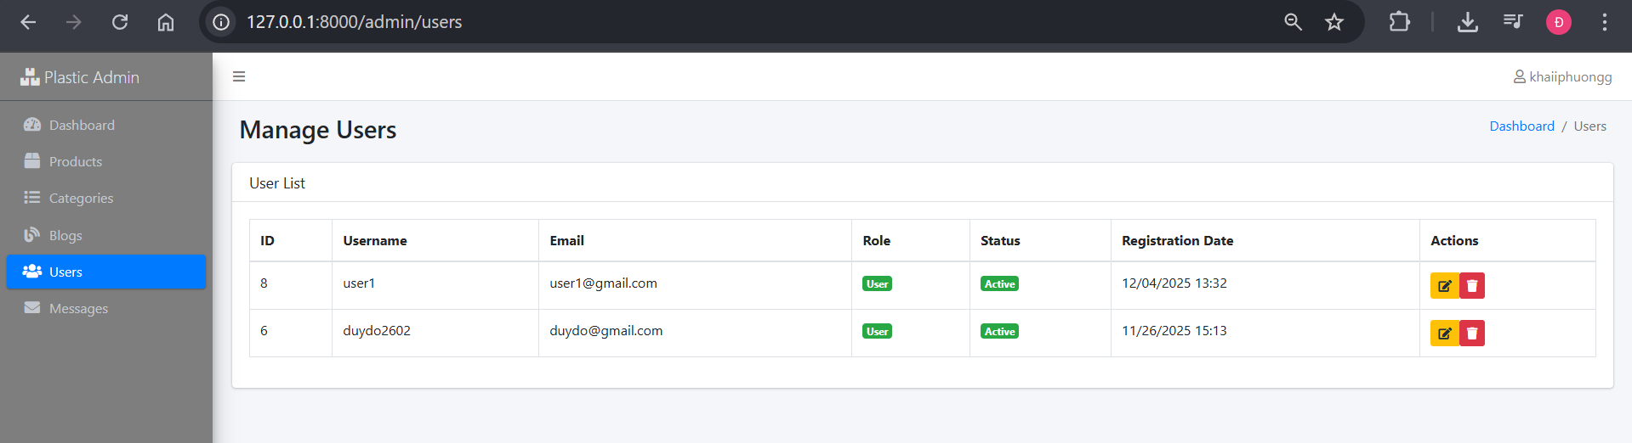

Image B4.1: Main Users Management View

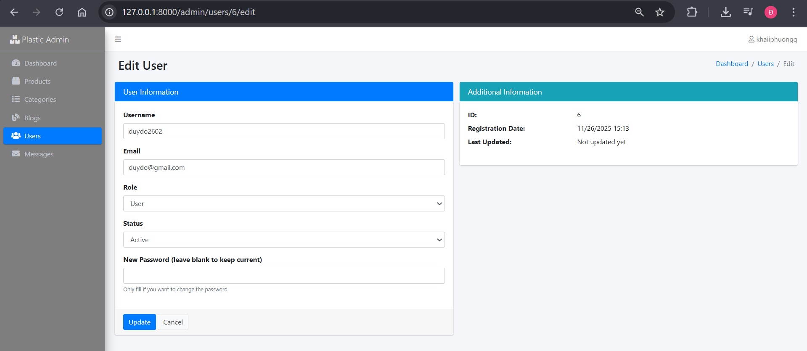

Image B4.2: User Edit View

* + 1. **Messages**

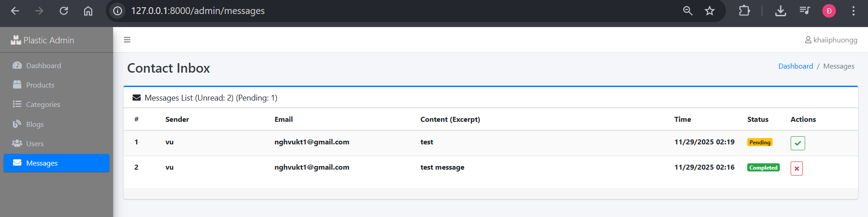

Image B5: Contact Management View

* + 1. **Reviews**

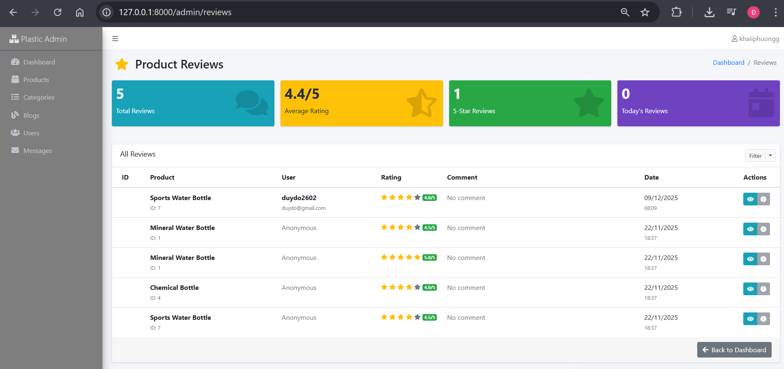

Image B6: Reviews Management View

* + 1. **Visitor count**

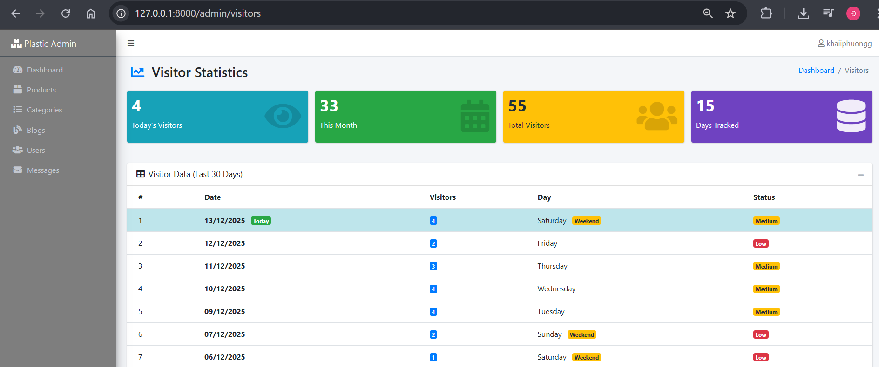

Image B7: Visitor Tracking View

1. **Run Web Application (Web User):**
   1. **Header / Footer**



Image 4A.1: Web Header

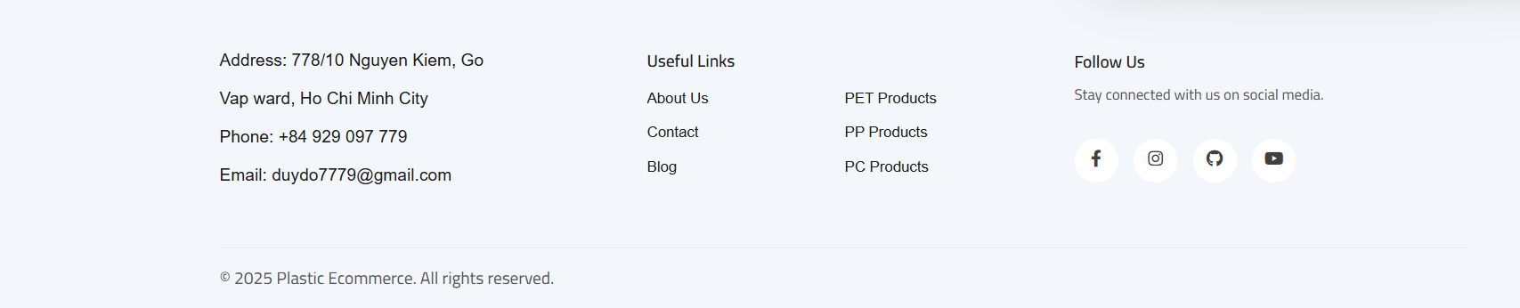

Image 4A.2: Web Footer

* 1. **Home**



Image 4B.1: Div links to Product page



Image 4B.2: Div introduces PolySite Organization

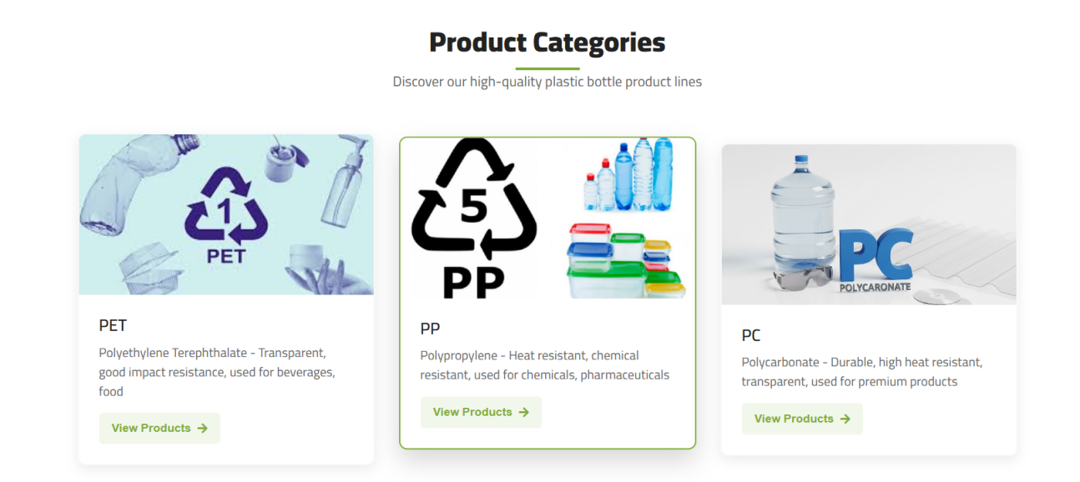

Image 4B.3: Div links to Categories sort

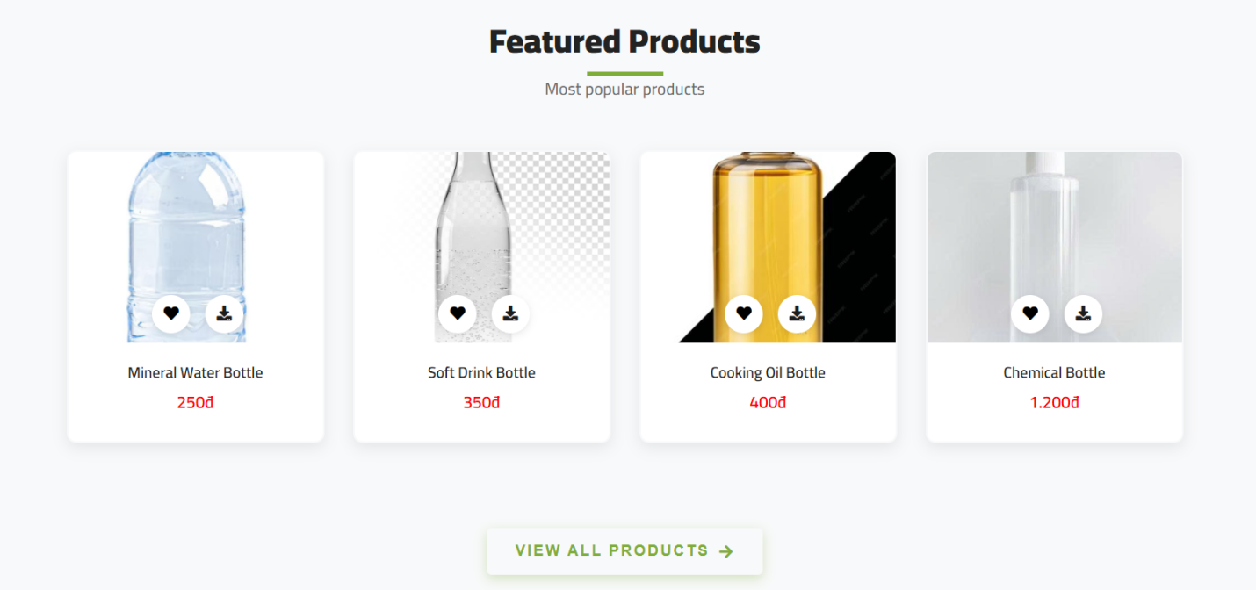

Image 4B.4: Div links to Product page

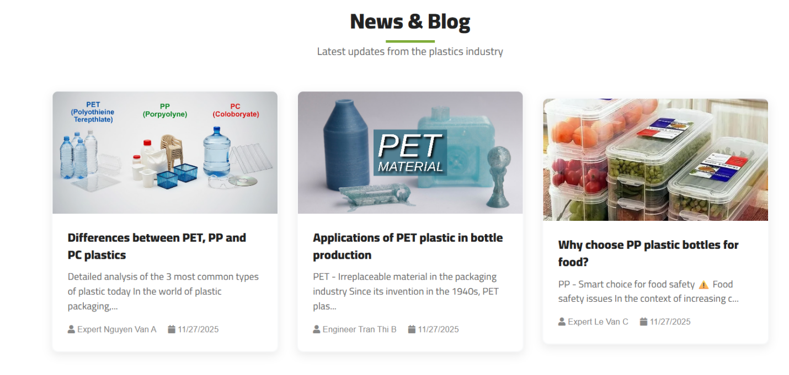

Image 4B.5: Div links to Blog page



Image 4B.6: Div links to Contact page

* 1. **Login**

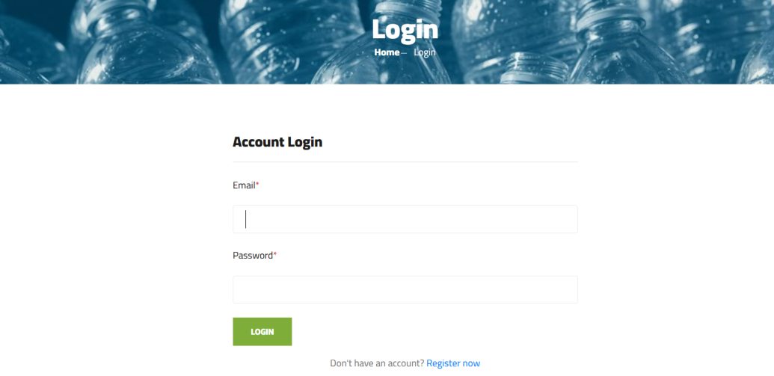

Image 4C: Login View

* 1. **Register**

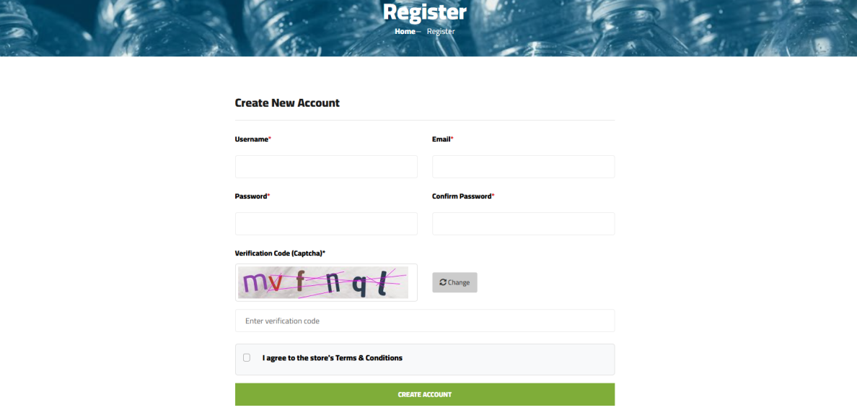

Image 4D: Register View

* 1. **Profile / Logout**

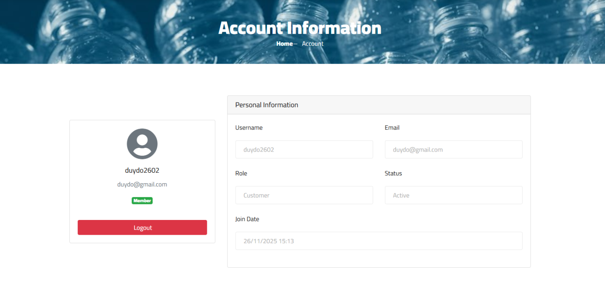

Image 4E: User Profile View and Logout

* 1. **About Us**



Image 4F.1: Div to introduce PolySite Organization

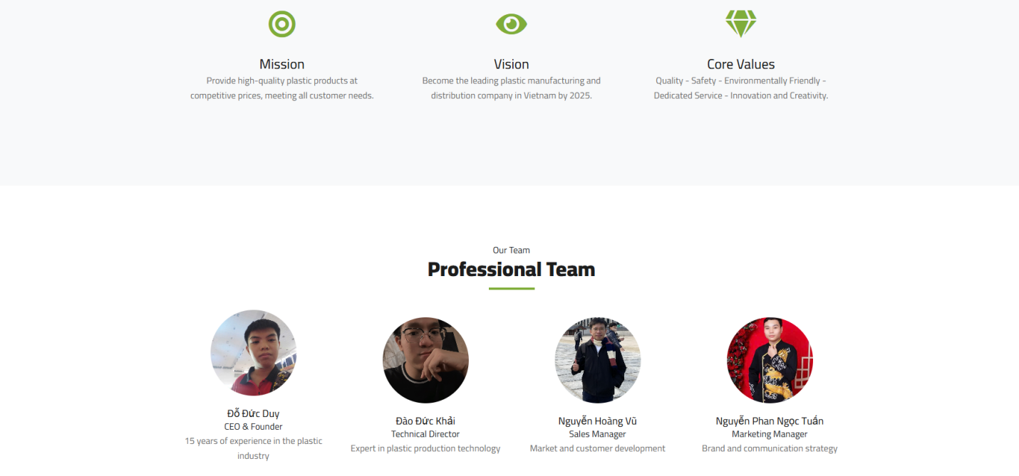

Image 4F.2: Div to introduce members

* 1. **Contact**

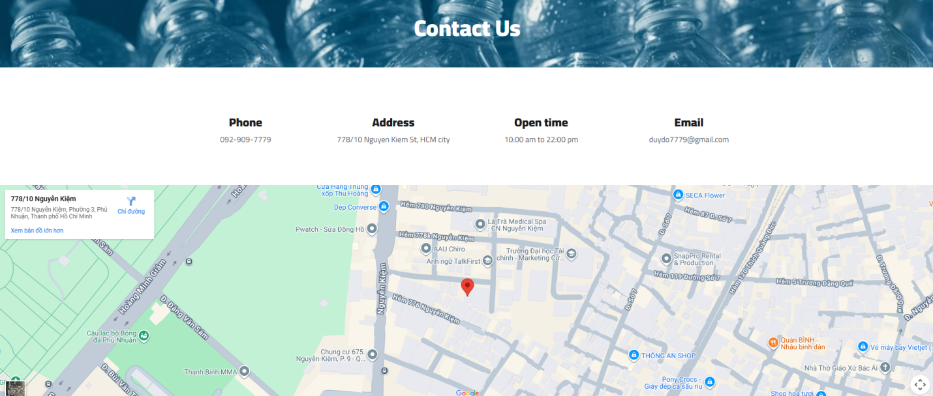

Image 4G: Contact info & map

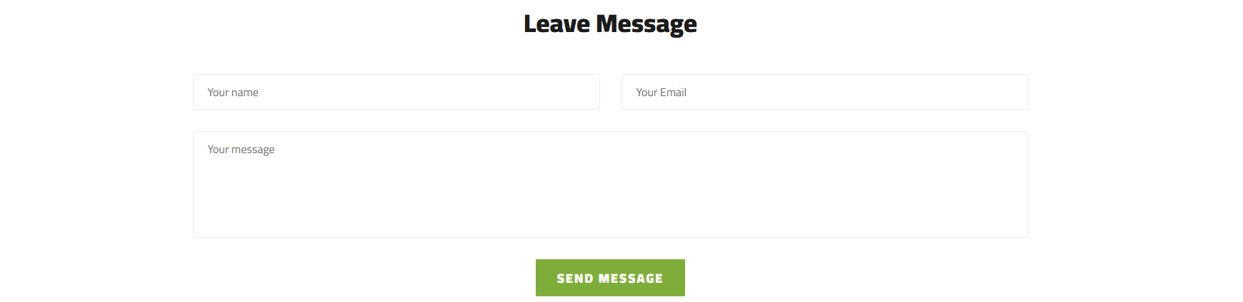

Image 4F: Div to leave message

* 1. **Products**

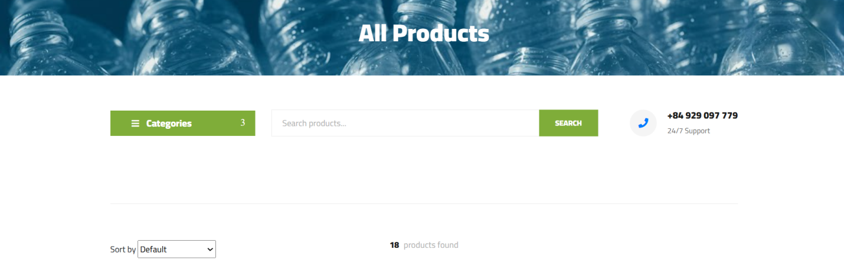

Image 4H.1: Price and categories sorting

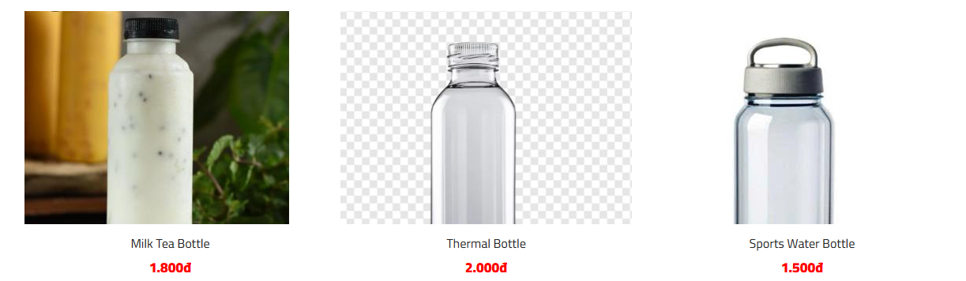

Image 4H.2: Product listing

* 1. **Blogs**

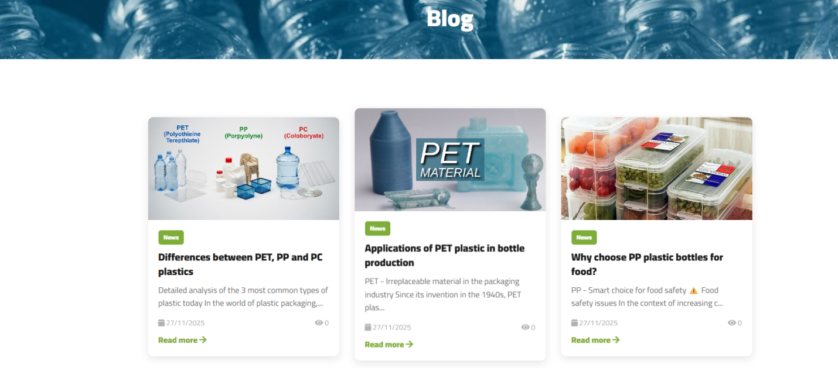

Image 4I.1: Main Blog page

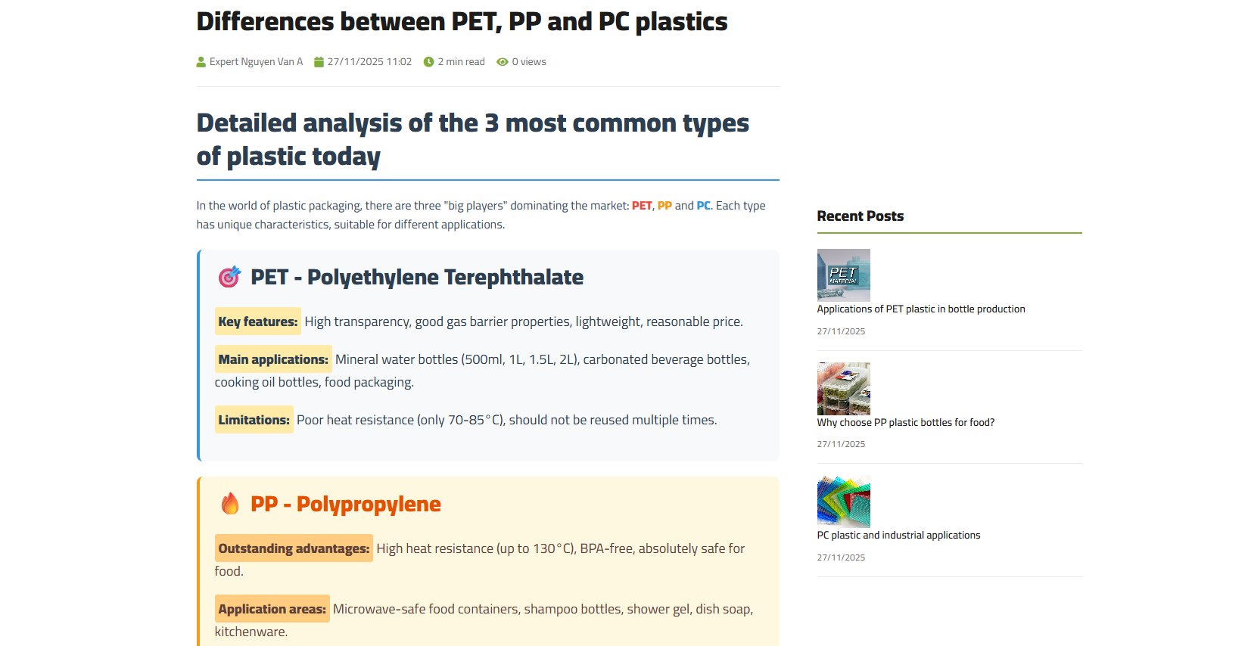

Image 4I.2: Blog Detail view

* 1. **AI Assistant**

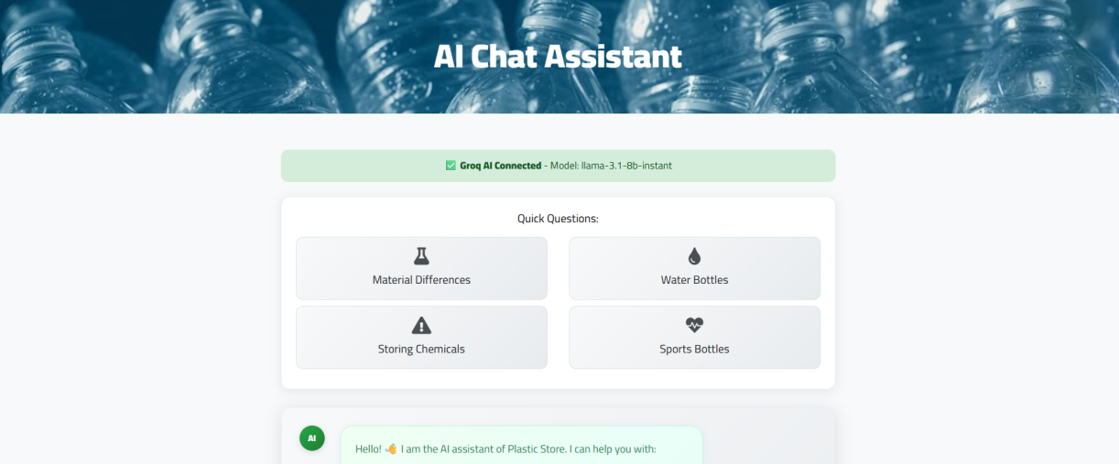

Image 4J.1: Prompting suggestions

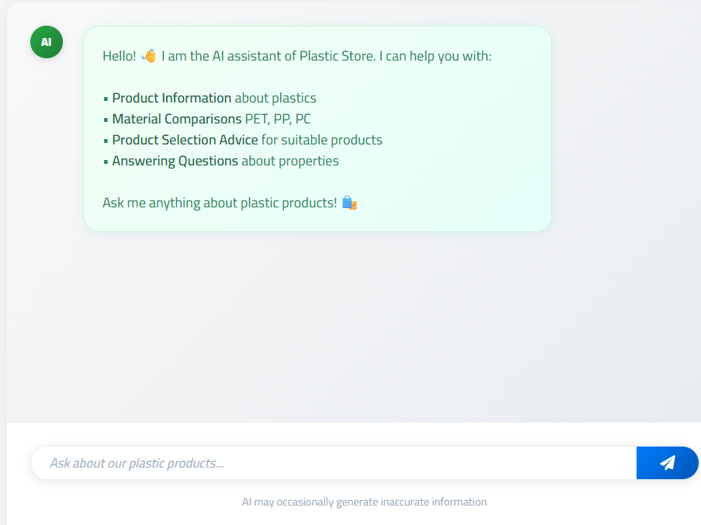

Image 4J.2: Chatting view

1. **Database:**
   1. **ER Diagram**

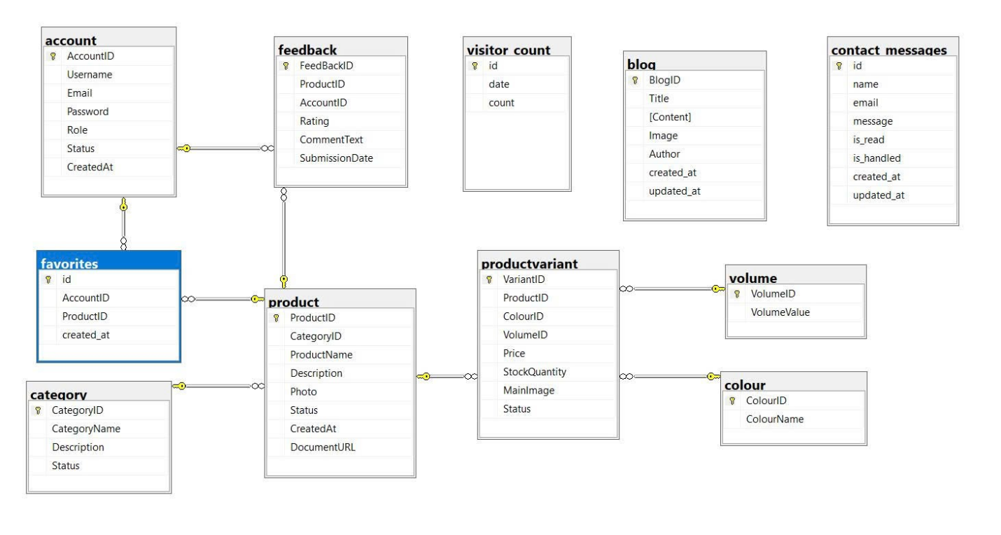

* 1. **Detail tables**
     1. **account**

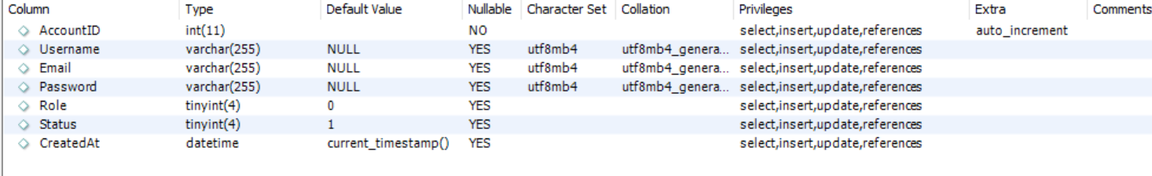

* + 1. **blog**

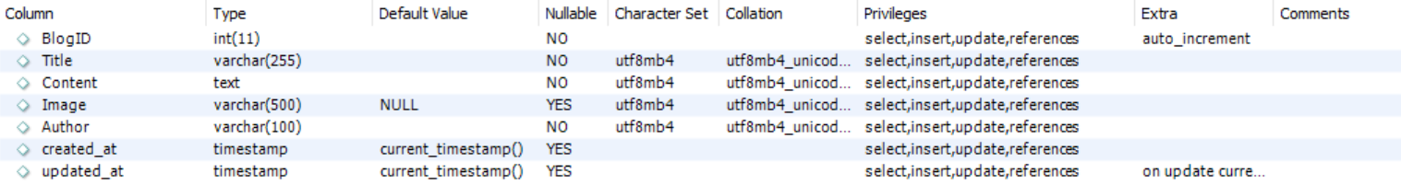

* + 1. **category**



* + 1. **colour**



* + 1. **contact_messages**

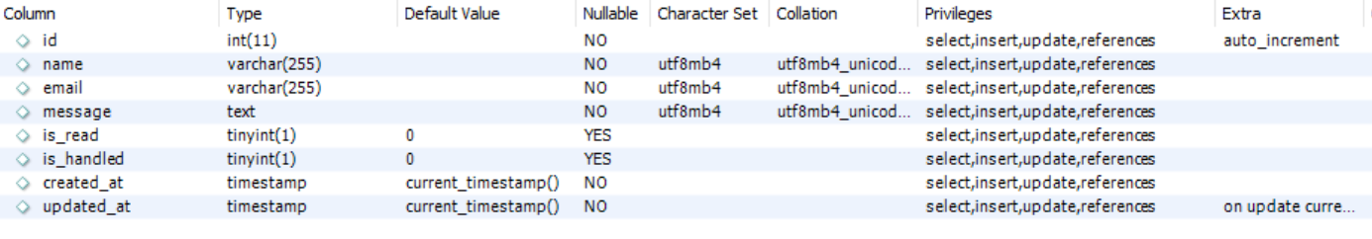

* + 1. **favorites**

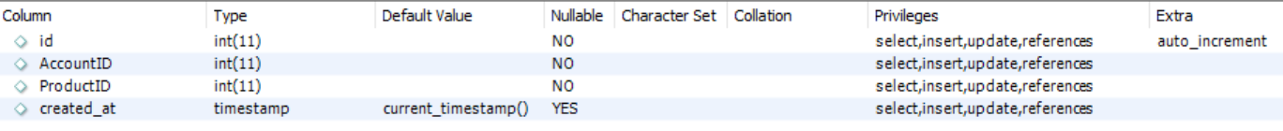

* + 1. **feedback**

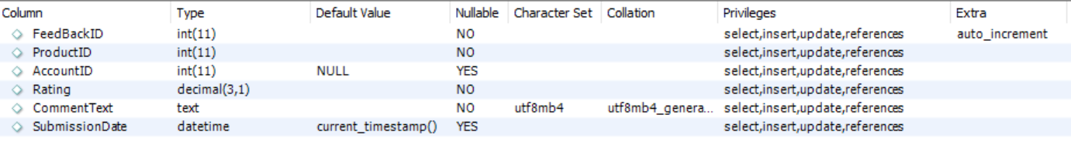

* + 1. **product**

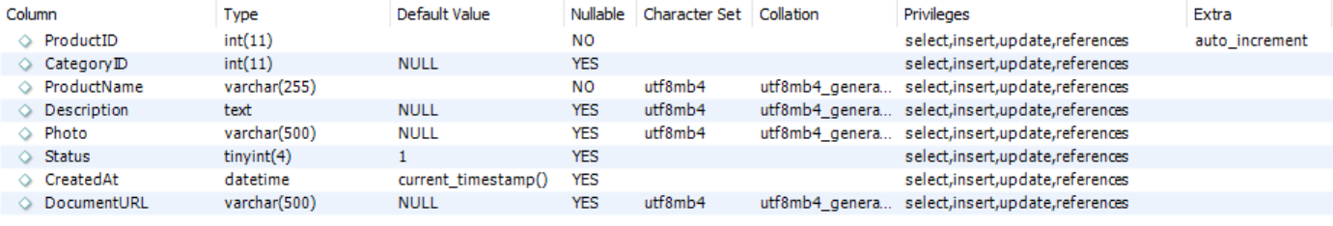

* + 1. **productvariant**

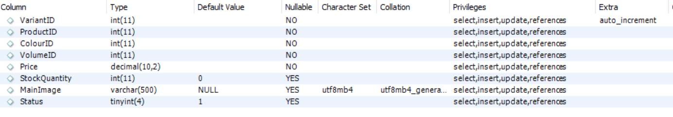

* + 1. **visitor_count**



* + 1. **volume**



1. **Contribution:**



